EWMA correlation: NZDUSD and USDCHF
Method 06 / daily log returns / lambda = 0.94 / Alpari D1 full available history

Study setup
Logical pair: NZDUSD , USDCHF
Broker symbols: NZDUSD_i , USDCHF_i
Snapshot: 2026-11-03_majors_alpari_D1
Timeframe: D1
Matched return window: 1999-01-05 to 2026-11-02 (UTC bar dates)
Matched return count n: 7185
Dropped unfinished last bar dated 2026-11-03 UTC after a tick-volume check against the prior complete day.
Lambda: 0.94 (today weight 0.06)
Burn-in ignored in path summaries and chart: first 60 updates
Mean adjustment: each leg demeaned by its mean on the matched rows
Seeds: c_0 = v_x,0 = v_y,0 = 0
Complete matched rows (Excel): NZDUSD-USDCHF_EWMA_D1.xlsx
Complete matched rows (HTML table): NZDUSD-USDCHF_EWMA_D1_data.html

Method carried forward
EWMA correlation updates covariance and variances of mean-adjusted daily log returns of close, ln(close_t / close_t-1), with lambda = 0.94 (6% weight on today's product or square, 94% on yesterday's EWMA state). Quotes are not inverted. Each leg is demeaned by its mean on the matched rows; that mean uses the full sample, so the rho path is a full-sample description, not a live filter. Seeds start at zero. Path summaries and the chart ignore the first 60 updates so the zero seed has faded. The headline is rho on the last day. rho is symmetric under swap of the two symbols. A high |rho| does not prove cause, lead-lag, or a trading signal. Today's return sits inside today's rho, so the estimate can only inform a later decision. Same-sample Pearson r is a side check only.

Results
Latest EWMA rho: -0.224004
Post-burn-in path (n=7125): mean=-0.443703, median=-0.476079, min=-0.869275, max=0.368719, std=0.216486
Share of post-burn-in days with |rho| >= 0.4: 62.92%; |rho| >= 0.7: 9.91%
Same-sample Pearson r: -0.393600
Latest rho minus r: 0.169596

Conclusion
Over 7185 matched daily log-return rows for NZDUSD and USDCHF (broker quote directions unchanged), latest EWMA rho with lambda=0.94 is -0.2240 (negative, weak recent linear link in this sample). After a 60-day burn-in, path mean is -0.4437, std is 0.2165, and the range is [-0.8693, 0.3687]. Same-sample Pearson r is -0.3936 (latest rho minus r = 0.1696). This does not establish cause, lead-lag, or a lasting trading rule.

Charts
Daily closes

Daily log returns
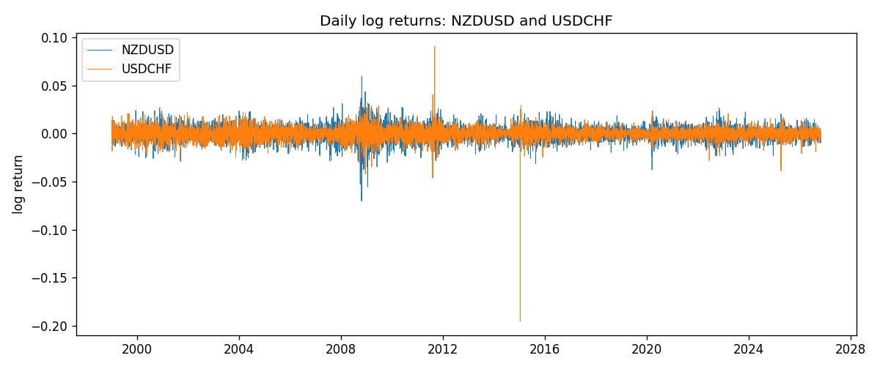
EWMA rho path with Pearson r reference
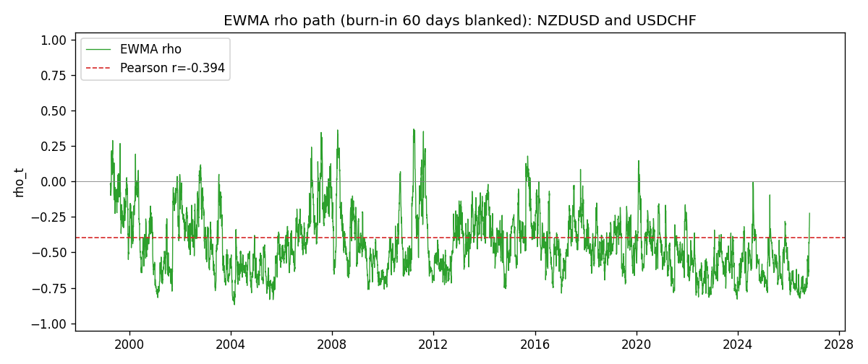

Data report
Every matched row that entered the EWMA recursion is stored in the sibling Excel workbook named NZDUSD-USDCHF_EWMA_D1.xlsx. That file is the complete data archive for redrawing charts. Embedding all rows as a Word table is impractical at this length; the Word file holds the column list, column summaries, and the first and last 15 matched rows.
Columns: time, NZDUSD_open, USDCHF_open, NZDUSD_high, USDCHF_high, NZDUSD_low, USDCHF_low, NZDUSD_close, USDCHF_close, NZDUSD_tick_volume, USDCHF_tick_volume, NZDUSD_spread, USDCHF_spread, NZDUSD_real_volume, USDCHF_real_volume, NZDUSD_log_return, USDCHF_log_return, NZDUSD_x_demeaned, USDCHF_y_demeaned, c_t, v_x, v_y, rho_t
Column summaries (matched calculation rows)
column | count | mean | std | min | 25% | 50% | 75% | max
NZDUSD_open | 7185 | 0.65641395 | 0.10821881 | 0.3913 | 0.59137 | 0.6684 | 0.72499 | 0.88218
USDCHF_open | 7185 | 1.0976269 | 0.25248305 | 0.72022 | 0.92053 | 0.98988 | 1.2378 | 1.8219
NZDUSD_high | 7185 | 0.66033247 | 0.10871106 | 0.3961 | 0.59478 | 0.672 | 0.72937 | 0.88421
USDCHF_high | 7185 | 1.1029176 | 0.25422469 | 0.73305 | 0.92474 | 0.99353 | 1.2423 | 1.8313
NZDUSD_low | 7185 | 0.65272894 | 0.10781325 | 0.3897 | 0.58811 | 0.66417 | 0.72099 | 0.87988
USDCHF_low | 7185 | 1.0925083 | 0.25089773 | 0.08565 | 0.91719 | 0.98622 | 1.2317 | 1.8121
NZDUSD_close | 7185 | 0.65649284 | 0.10821292 | 0.3907 | 0.59165 | 0.6684 | 0.72502 | 0.8822
USDCHF_close | 7185 | 1.0976163 | 0.25237603 | 0.72025 | 0.92079 | 0.98995 | 1.2379 | 1.8217
NZDUSD_tick_volume | 7185 | 68718.644 | 123140.12 | 16 | 5587 | 33899 | 58511 | 1127682
USDCHF_tick_volume | 7185 | 74335.19 | 113494.16 | 18 | 12810 | 40241 | 70443 | 858589
NZDUSD_spread | 7185 | 30.278775 | 25.647496 | 0 | 9 | 17 | 40 | 80
USDCHF_spread | 7185 | 26.036326 | 24.697816 | 0 | 5 | 16 | 50 | 100
NZDUSD_real_volume | 7185 | 1.6703703e+10 | 8.4983725e+10 | 0 | 0 | 0 | 0 | 2.705649e+12
USDCHF_real_volume | 7185 | 2.3294091e+10 | 8.9133595e+10 | 0 | 0 | 0 | 0 | 1.9331921e+12
NZDUSD_log_return | 7185 | 2.019e-05 | 0.00763908 | -0.07027433 | -0.0042485 | 0.00023717 | 0.00458461 | 0.05966839
USDCHF_log_return | 7185 | -7.205e-05 | 0.00658891 | -0.19545699 | -0.0033516 | 8.095e-05 | 0.00331593 | 0.09051364
NZDUSD_x_demeaned | 7185 | 0 | 0.00763908 | -0.07029452 | -0.00426869 | 0.00021699 | 0.00456443 | 0.0596482
USDCHF_y_demeaned | 7185 | 0 | 0.00658891 | -0.19538494 | -0.00327955 | 0.000153 | 0.00338798 | 0.09058569
c_t | 7185 | -1.98e-05 | 1.936e-05 | -0.00020118 | -2.599e-05 | -1.496e-05 | -8.23e-06 | 4.578e-05
v_x | 7185 | 5.831e-05 | 5.894e-05 | 2.1e-07 | 3.043e-05 | 4.23e-05 | 6.666e-05 | 0.00086281
v_y | 7185 | 4.337e-05 | 9.02e-05 | 9.7e-07 | 1.84e-05 | 2.956e-05 | 4.744e-05 | 0.00231221
rho_t | 7185 | -0.43871248 | 0.22326245 | -1 | -0.60524859 | -0.47260262 | -0.31157646 | 0.55029693
First 15 matched rows (selected columns)
time | NZDUSD_close | USDCHF_close | NZDUSD_log_return | USDCHF_log_return | NZDUSD_x_demeaned | USDCHF_y_demeaned | c_t | v_x | v_y | rho_t
1999-01-05 | 0.5372 | 1.3724 | -0.0018597736 | 0.0039424743 | -0.001879962 | 0.004014527 | -4.5282949e-07 | 2.1205543e-07 | 9.669856e-07 | -1
1999-01-06 | 0.5383 | 1.3912 | 0.0020455609 | 0.013605652 | 0.0020253725 | 0.013677705 | 1.2364871e-06 | 4.4546014e-07 | 1.2133743e-05 | 0.53184831
1999-01-07 | 0.5417 | 1.3782 | 0.0062963171 | -0.0093883841 | 0.0062761287 | -0.0093163314 | -2.3459318e-06 | 2.78212e-06 | 1.661336e-05 | -0.34506325
1999-01-08 | 0.5414 | 1.3935 | -0.00055396548 | 0.011040268 | -0.00057415387 | 0.011112321 | -2.5879868e-06 | 2.634972e-06 | 2.3025579e-05 | -0.3322529
1999-01-11 | 0.547 | 1.4009 | 0.010290425 | 0.0052963193 | 0.010270237 | 0.005368372 | 8.753595e-07 | 8.8055396e-06 | 2.3373209e-05 | 0.061016781
1999-01-12 | 0.5441 | 1.3872 | -0.0053157489 | -0.0098275602 | -0.0053359373 | -0.0097555075 | 3.9461245e-06 | 9.9855408e-06 | 2.7681012e-05 | 0.23735261
1999-01-13 | 0.5387 | 1.3621 | -0.0099742238 | -0.018259701 | -0.0099944122 | -0.018187648 | 1.4615848e-05 | 1.5379705e-05 | 4.5867584e-05 | 0.55029693
1999-01-14 | 0.5386 | 1.3588 | -0.00018564931 | -0.0024256692 | -0.00020583769 | -0.0023536165 | 1.3767965e-05 | 1.4459465e-05 | 4.3447899e-05 | 0.54929956
1999-01-15 | 0.5382 | 1.3834 | -0.00074294208 | 0.01794228 | -0.00076313047 | 0.018014333 | 1.211705e-05 | 1.3626839e-05 | 6.0311996e-05 | 0.42266616
1999-01-18 | 0.5372 | 1.379 | -0.0018597736 | -0.0031856384 | -0.001879962 | -0.0031135857 | 1.1741232e-05 | 1.3021284e-05 | 5.7274941e-05 | 0.42993663
1999-01-19 | 0.5382 | 1.3789 | 0.0018597736 | -7.2518946e-05 | 0.0018395853 | -4.6625124e-07 | 1.1036707e-05 | 1.2443051e-05 | 5.3838445e-05 | 0.42641238
1999-01-20 | 0.5404 | 1.3889 | 0.0040793678 | 0.0072259871 | 0.0040591794 | 0.0072980398 | 1.2151948e-05 | 1.2685085e-05 | 5.3803821e-05 | 0.46514959
1999-01-21 | 0.5426 | 1.3836 | 0.0040627941 | -0.0038232689 | 0.0040426058 | -0.0037512162 | 1.0512949e-05 | 1.2904539e-05 | 5.1419889e-05 | 0.40811989
1999-01-22 | 0.5361 | 1.3834 | -0.012051689 | -0.0001445609 | -0.012071878 | -7.2508202e-05 | 9.9346911e-06 | 2.0874081e-05 | 4.8335011e-05 | 0.31276617
1999-01-25 | 0.5342 | 1.3868 | -0.0035504102 | 0.0024546976 | -0.0035705985 | 0.0025267503 | 8.797289e-06 | 2.0386586e-05 | 4.5817979e-05 | 0.28784497
Last 15 matched rows (selected columns)
time | NZDUSD_close | USDCHF_close | NZDUSD_log_return | USDCHF_log_return | NZDUSD_x_demeaned | USDCHF_y_demeaned | c_t | v_x | v_y | rho_t
2026-10-13 | 0.56127 | 0.83244 | 0.0047326165 | -0.0024955621 | 0.0047124281 | -0.0024235094 | -9.061403e-06 | 1.6986599e-05 | 1.3297685e-05 | -0.60291238
2026-10-14 | 0.55918 | 0.83489 | -0.0037306483 | 0.0029388325 | -0.0037508366 | 0.0030108852 | -9.1953191e-06 | 1.681153e-05 | 1.304375e-05 | -0.62095762
2026-10-15 | 0.56185 | 0.82676 | 0.0047634855 | -0.0097855323 | 0.0047432971 | -0.0097134796 | -1.1408035e-05 | 1.715277e-05 | 1.7922226e-05 | -0.65065046
2026-10-16 | 0.56509 | 0.82377 | 0.0057501001 | -0.0036230826 | 0.0057299118 | -0.0035510299 | -1.1944378e-05 | 1.8093517e-05 | 1.7603481e-05 | -0.66927218
2026-10-19 | 0.56616 | 0.82677 | 0.0018917133 | 0.0036351779 | 0.0018715249 | 0.0037072306 | -1.0811425e-05 | 1.7218062e-05 | 1.7371886e-05 | -0.62512565
2026-10-20 | 0.56827 | 0.8246 | 0.0037199341 | -0.0026281224 | 0.0036997457 | -0.0025560697 | -1.0730148e-05 | 1.7006266e-05 | 1.6721582e-05 | -0.63630092
2026-10-21 | 0.57003 | 0.82427 | 0.0030923331 | -0.00040027413 | 0.0030721448 | -0.00032822144 | -1.014684e-05 | 1.6552174e-05 | 1.5724751e-05 | -0.62894315
2026-10-22 | 0.56815 | 0.82032 | -0.0033035227 | -0.0048036381 | -0.003323711 | -0.0047315854 | -8.5944441e-06 | 1.6221867e-05 | 1.612454e-05 | -0.53140264
2026-10-23 | 0.56991 | 0.82497 | 0.0030929853 | 0.005652514 | 0.0030727969 | 0.0057245667 | -7.0233516e-06 | 1.581508e-05 | 1.7123308e-05 | -0.42679064
2026-10-26 | 0.56826 | 0.82649 | -0.0028993932 | 0.0018407959 | -0.0029195815 | 0.0019128486 | -6.9370336e-06 | 1.5377612e-05 | 1.6315448e-05 | -0.43795535
2026-10-27 | 0.56811 | 0.82865 | -0.00026399852 | 0.0026100526 | -0.0002841869 | 0.0026821053 | -6.5665447e-06 | 1.4459801e-05 | 1.5768143e-05 | -0.43487603
2026-10-28 | 0.56261 | 0.82781 | -0.0097283914 | -0.0010142111 | -0.0097485798 | -0.00094215842 | -5.6214696e-06 | 1.9294302e-05 | 1.4875314e-05 | -0.33181977
2026-10-29 | 0.56296 | 0.82379 | 0.00062190714 | -0.0048680164 | 0.00060171876 | -0.0047959637 | -5.4573307e-06 | 1.8158368e-05 | 1.5362871e-05 | -0.32674254
2026-10-30 | 0.56307 | 0.82438 | 0.00019537668 | 0.00071594559 | 0.0001751883 | 0.00078799829 | -5.121608e-06 | 1.7070707e-05 | 1.4478356e-05 | -0.32577741
2026-11-02 | 0.56161 | 0.81851 | -0.0025962955 | -0.0071459744 | -0.0026164839 | -0.0070739218 | -3.7037834e-06 | 1.6457224e-05 | 1.6612076e-05 | -0.22400377

